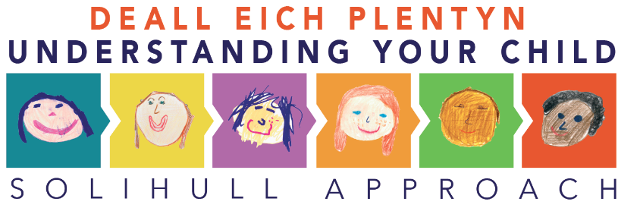
Script for promoting the scheme
I wanted to let you know about Solihull Approach online courses that are available exclusively free of charge from April 2020 to November 2022 for all residents of North Wales.
The courses are really informative and interesting! They look at the baby / child’s / teenager brain development, play, styles of parenting, sleep, temper tantrums, communication and many more!
Emotional health and wellbeing of parents, grandparents, carers and the infant/child/teenager are explored within the courses. The courses are based on evidence, have been written by registered professionals, and are recognised by NHS providers and accredited by the Department of Education (DfE).
The courses are split into 4 sections, you can do them all or choose which one’s are most relevant to you:
      - Understanding Pregnancy, Labour, Birth and your Baby
      - Understanding your Baby
      - Understanding your Child
      - Understanding your Teenagers Brain (is a shorter course)
There is a wealth of useful tips and information within all of the courses, there are between 9 – 11 modules within each course. Each takes around 20 minutes to complete, and have plenty of variation from interactive activities, quizzes, video clips and practical handouts.
I would recommend that you do at least one session a week, there are activities that you can try out in between your online sessions as well. Once you have completed each course you will receive a certificate.
If you are interested in exploring these courses further yourself, please go to www.inourplace.co.uk to register and enter our exclusive access code for North Wales which is NWSOL. Also Solihull Approach North Wales have Facebook and Twitter pages which you could follow both social media platforms are called Solihull Approach North Wales.

I hope you enjoy the courses and please do feel free to pass on the access code to any friends or relatives who are residents within North Wales.
If you would like to let us know what you thought of the courses, please send us any feedback or comments to: nwsol@wales.nhs.uk

